

**Module Code & Module Title**

**CC4057NI Introduction to Information Systems**

**Assessment Weightage & Type**

**40% Individual Coursework**

**Year and Semester**

**2021-22 Spring**

**Student Name: Abhijan Basyal**

**Group: C13**

**London Met ID: 22015639**

**College ID:** **NP01CP4S220138**

**Assignment Due Date: 1st June, 2022**

**Assignment Submission Date: 1st June, 2022**

*I confirm that I understand my coursework needs to be submitted online via Google Classroom under the relevant module page before the deadline in order for my assignment to be accepted and marked. I am fully aware that late submissions will be treated as non-submission and a marks of zero will be awarded.*

Table of Contents

**1.** **INTRODUCTION** 1

1.1 Introduction of my project 1

1.2 Goals and objectives 1

1.3 Use of HTML, CSS and JavaScript while developing the website 1

1.4 Verdict 2

**2.** **TOOLS USED** 3

2.1 Sublime text 3

2.2 Balsamiq wireframes 3

**3. NAME OF PAGE** 4

3.1 Home Page 4

**3.1.1 Wireframe of Home Page** 4

**3.1.2 The Actual Home Page** 4

3.2 Products page 5

**3.2.1 Wireframe of Products Page** 6

**3.2.2 The Actual Product Page** 7

3.3 Blog Page 8

**3.3.1 Wireframe of Blog Page** 8

**3.3.2 The Actual Blog Page** 9

3.4 Research Page 10

**3.4.1 Wireframe of Research Page** 10

3.5 Contact US Page 13

**3.5.1 Wireframe of Contact US Page** 13

**3.5.2 The Actual Contact us Page** 14

**4. TESTING** 15

4.1 Test 1 15

4.2 Test 2 18

4.3 Test 3 20

4.4 Test 4 23

4.5 Test 5 25

**5. CONCLUSION** 29

**BIBLIOGRAPHY** 30

**APPENDIX** 31

**List of Figures**

Figure 1 Balsamiq of Home Page 4

Figure 2 Home Page-1 5

Figure 3 Home Page - 2 5

Figure 4 Balsamiq of Products Page 6

Figure 5 Products Page 1 7

Figure 6 Products Page 2 7

Figure 7 Balsamiq of Blog page 8

Figure 8 Blog Page 1 9

Figure 9 Blog Page 2 9

Figure 10 Balsamiq of Research page 10

Figure 11 Research Page 2 11

Figure 12 Research Page 1 11

Figure 13 Research Page 3 12

Figure 14 Balsamiq of Contact us Page 13

Figure 15 Contact Us Page 1 14

Figure 16 Contact Us Page 2 14

Figure 17 Test 1 screenshot 1 16

Figure 18 Test 1 screenshot 2 16

Figure 19 Test 1 screenshot 3 17

Figure 20 Test 1 screenshot 4 17

Figure 21 Test 2 screenshot 1 19

Figure 22 Test 2 screenshot 1 19

Figure 23 Test 3 screenshot 1 21

Figure 24 Test 3 screenshot 2 21

Figure 25 Test 3 screenshot 3 22

Figure 26 Test 3 screenshot 22

Figure 27 Test 4 screenshot 24

Figure 28 Test 5 screenshot 1 26

Figure 29 Test 5 screenshot 2 26

Figure 30 Test 5 screenshot 3 27

Figure 31 Test 5 screenshot 4 27

Figure 32 Test 5 screenshot 5 28

**List of Tables**

Table 1 Test 1 15

Table 2 Test 2 18

Table 3 Test 3 20

Table 4 Test 4 23

Table 5 Test 5 25

# **INTRODUCTION**

## 1.1 Introduction of my project

A website is a collection of linked web pages (together with their related resources  
) with a single domain name. Customer can buy and sell physical things, services, and digital products via the internet using a website to promote their business. This type of business is referred to as an Ecommerce business or a website where a variety of different types of business are conducted through a website. Many features, including as payments, shopping carts, and products, are featured in this type of website. In this .project, a website is constructed to assist an ecommerce firm in the context of mobile purchasing, and it is documented using a variety of software and tools such as Balsamiq wireframe, Sublime text, and Microsoft Word. The website is user-friendly and a buyer may readily obtain product information without difficulties.

## 1.2 Goals and objectives

My project’s goal was to create a mobile shopping website with a variety of features and user-friendly interface that included a variety of aspects. Images, buttons, hyperlinks, CSS, and JavaScript are examples. My main objectives were to create a proper webpage modification with nice CSS and a proper technique of linking to other pages with diverse content.

## 1.3 Use of HTML, CSS and JavaScript while developing the website

HTML stands for hypertext markup language which is the most basic aspect of webpage design, and is used to create a website’s structure. When the HTML gives the proper structure for the websites to make a user friendly for the user the CSS is used which stands for the Cascading Style Sheets. CSS modify the website by making it a good looking so that user can get easy to understand. They includes changing style and colouring of the website with a proper margin, border, and padding. After the implementation of HTML and CSS, JavaScript is applied. JavaScript is a programming language and also known as the scripting language which is used to make the movement of the webpage.

## 1.4 Verdict

The foundations of a professional website are HTML, CSS, and JavaScript. They serve as the foundation for the website. To execute certain task all this foundation are needed because this three are linked with each order if one is missed the all are missed. As a result, all HTML, CSS and JavaScript are necessary with its own features so that the function can easily be carried out.

# **TOOLS USED**

While designing the website tools were used such as for text editor sublime text is used and for wireframe balsamiq wireframes is used.

## 2.1 Sublime text

Sublime Text Editor is a full-featured text editor that can be used to edit local files or a code base. It has a number of tools for editing code that aid developers in keeping track of changes. Sublime Text is used as an Integrated Development Editor (IDE) like Visual Studio and NetBeans. The current version of sublime text editor is 3.0 and is compatible with various operating systems like Windows, Linux and MacOS. In sublime text we can use many beneficial features like ability to solved linker errors, keeping track of all files and folder to work with, connectivity with version control systems and so on. (Tutorials point, 2022)

## 2.2 Balsamiq wireframes

Balsamiq wireframes is a user interface design tool for creating wireframes (sometimes called mockups or low-fidelity prototypes). We can use it to generate digital sketches of our idea or concept for an application or website, to facilitate discussion and understanding before any code is written. The completed wireframes can be used for testing, clarifying our vision, getting feedback from stakeholders, or getting approval to start development. (Balsamiq Studios, LLC, 2008-2022)

# **3. NAME OF PAGE**

## 3.1 Home Page

A home page is the main web page of a website and also refer to the start page shown in a web browser when the application first opens (wikipedia, 2022). There are three section on my home page: header, main, and footer. Where the header includes the logo of my mobile shop on the left side and the name of my firm as palaz mobile shop after the logo. The navigation bar, which connects to other webpages, is similarly located in the header. Following that, in primary, there is a banner for mobile shopping advertising, as well as a mobile brand present in my shop after the banner. At the bottom of the page, in the footer, there is information about my firm, a free app for establishing my shop, and social media account where customers may follow us.

### **3.1.1 Wireframe of Home Page**

Figure 1 Balsamiq of Home Page

### **3.1.2 The Actual Home Page**

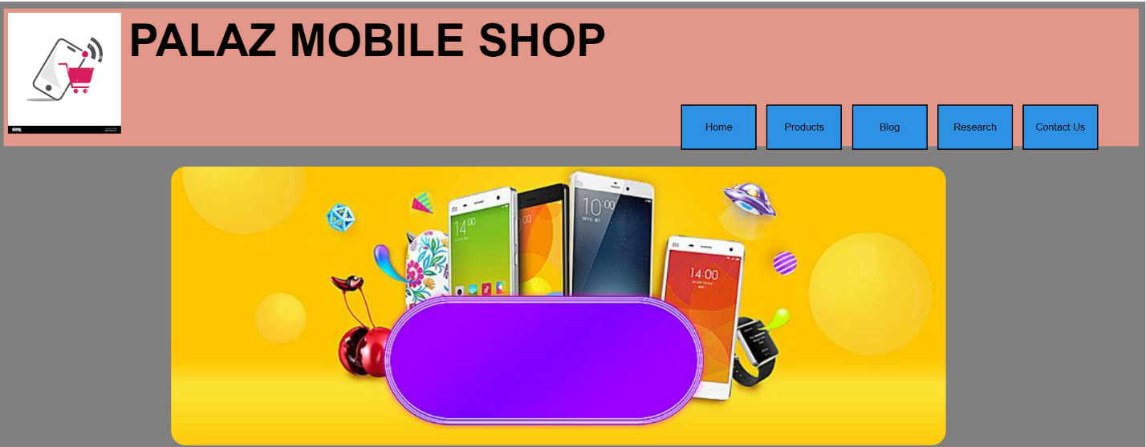

Figure 2 Home Page-1

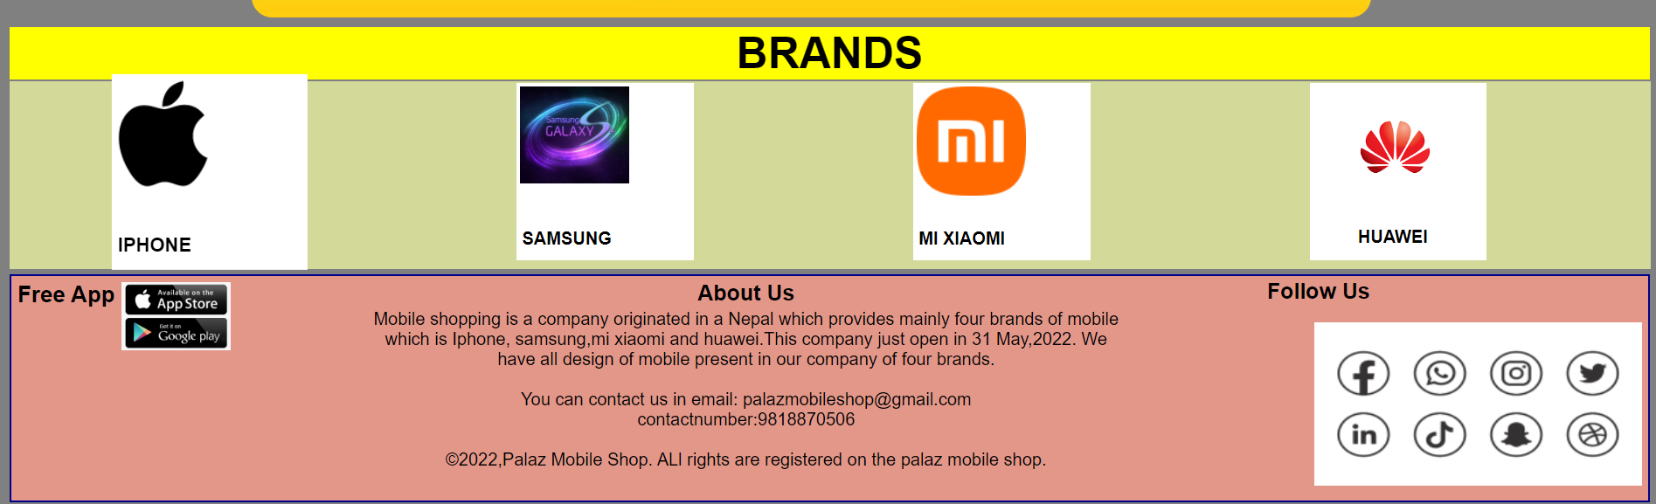

Figure 3 Home Page - 2

## 3.2 Products page

This webpage is about a collection of product show for a user in this mobile shop website. In this webpage different kinds of product are shown of brands iPhone, Samsung, MI xiaomi and Huawei. This webpage has the same header and footer of the homepage webpage. The changes is on the main part where the hover effect is put in all item represent in a product webpage and also the name and the price of mobile is shown in this webpage.

### **3.2.1 Wireframe of Products Page**

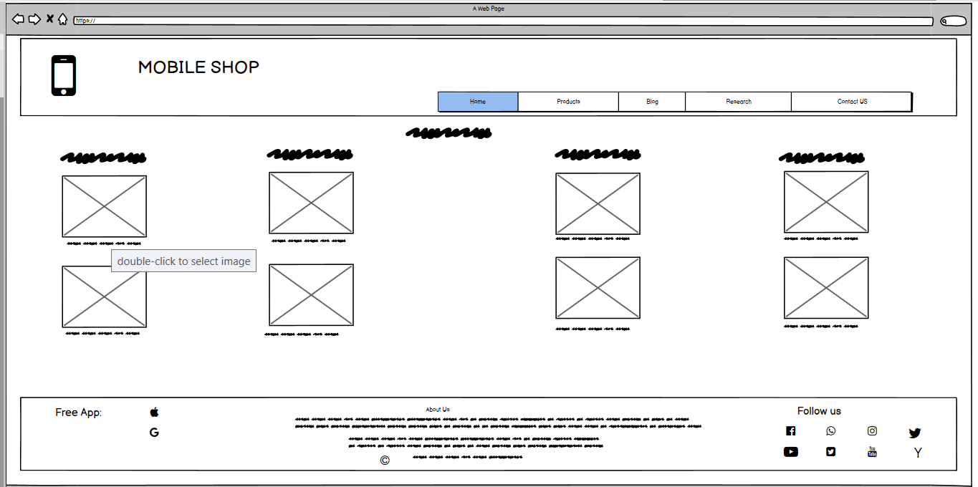

Figure 4 Balsamiq of Products Page

### **3.2.2 The Actual Product Page**

Figure 5 Products Page 1

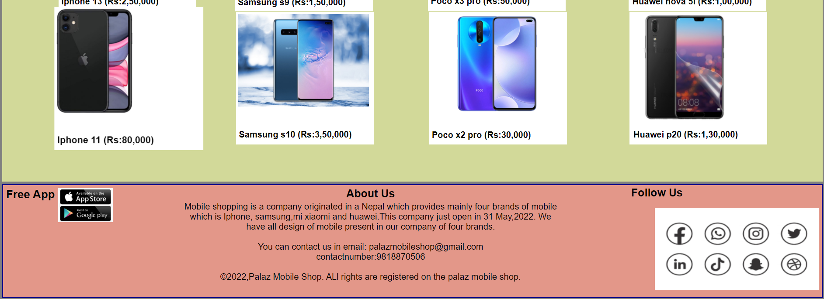

Figure 6 Products Page 2

## 3.3 Blog Page

This webpage is about introduction of a technology and the current status of a technology trending in a current time. This webpage also tell about the advantageous and disadvantageous of a technology. This webpage has the same header and footer of the homepage. The main changes is in the mid page of this website there is a description and images along with the topic.

### **3.3.1 Wireframe of Blog Page**

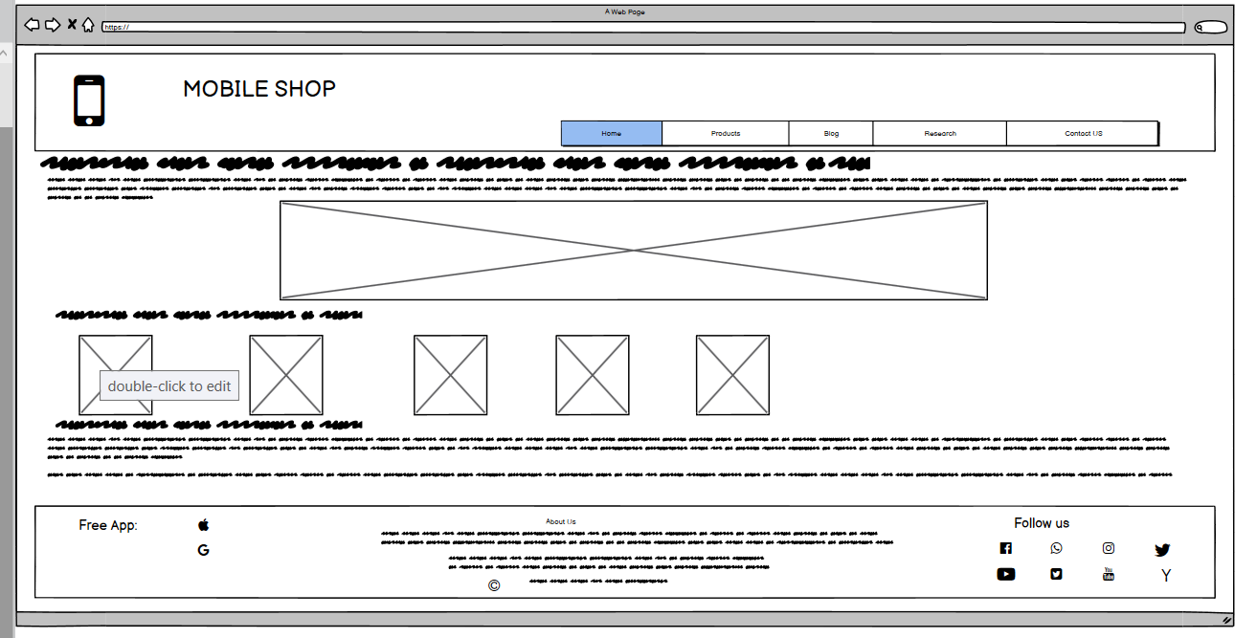

Figure 7 Balsamiq of Blog page

### **3.3.2 The Actual Blog Page**

Figure 8 Blog Page 1

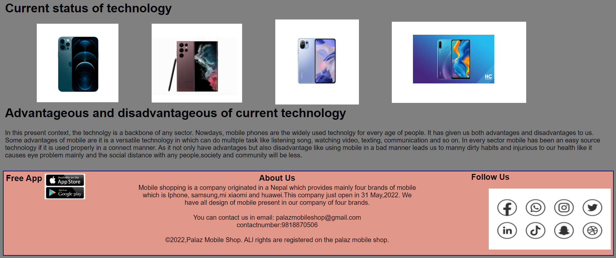

Figure 9 Blog Page 2

## 3.4 Research Page

This webpage is about a references taken from the other webpage for taking mainly ideas. In this webpage the header and the footer is same as the homepage. The changes is in the main that means in the middle where there is a website picture along with the description of what I take it from it and represent on it. This reference is put in a correct structure where at the left side there is a picture and at the right sider there is a description.

### **3.4.1 Wireframe of Research Page**

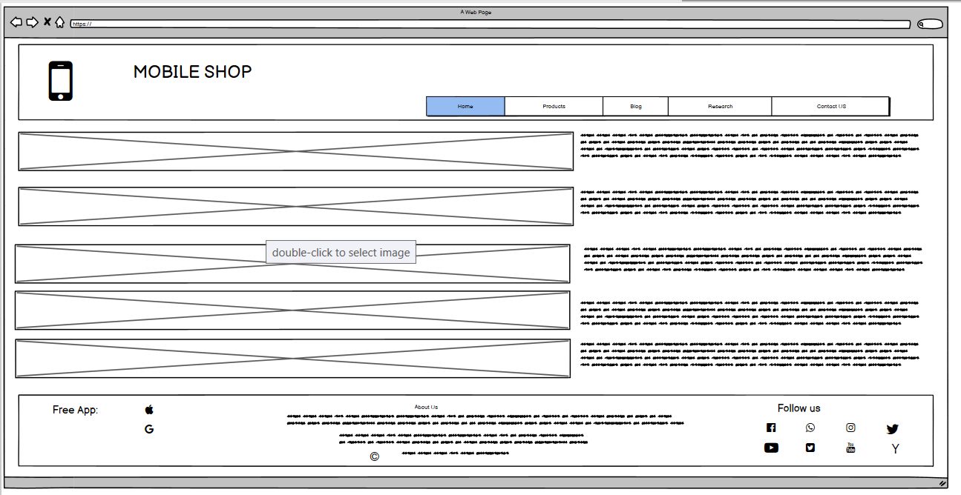

Figure 10 Balsamiq of Research page

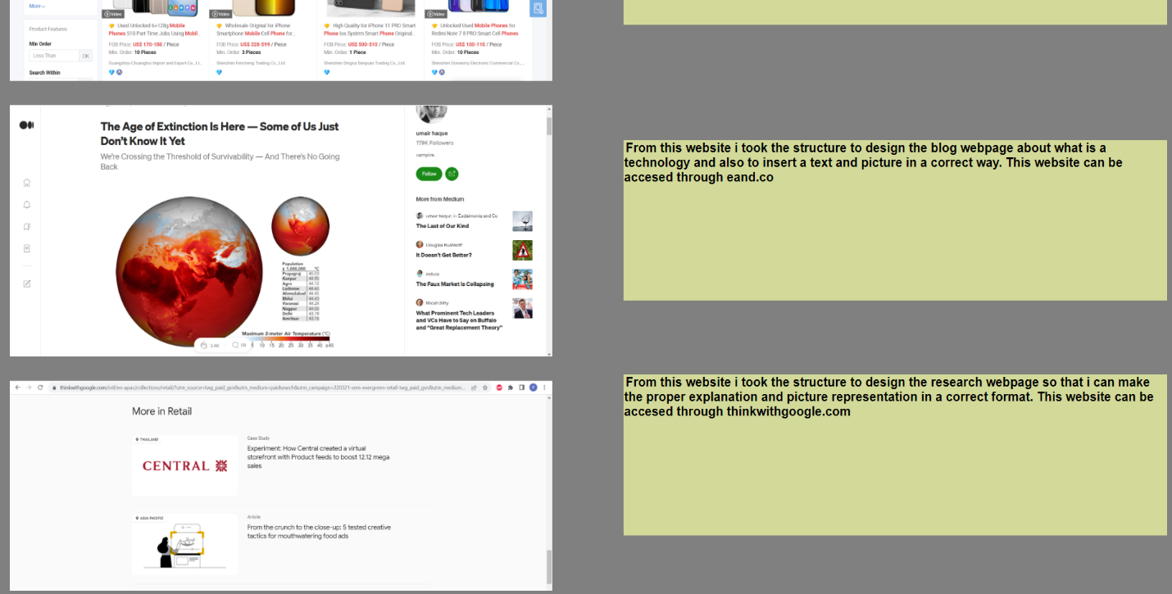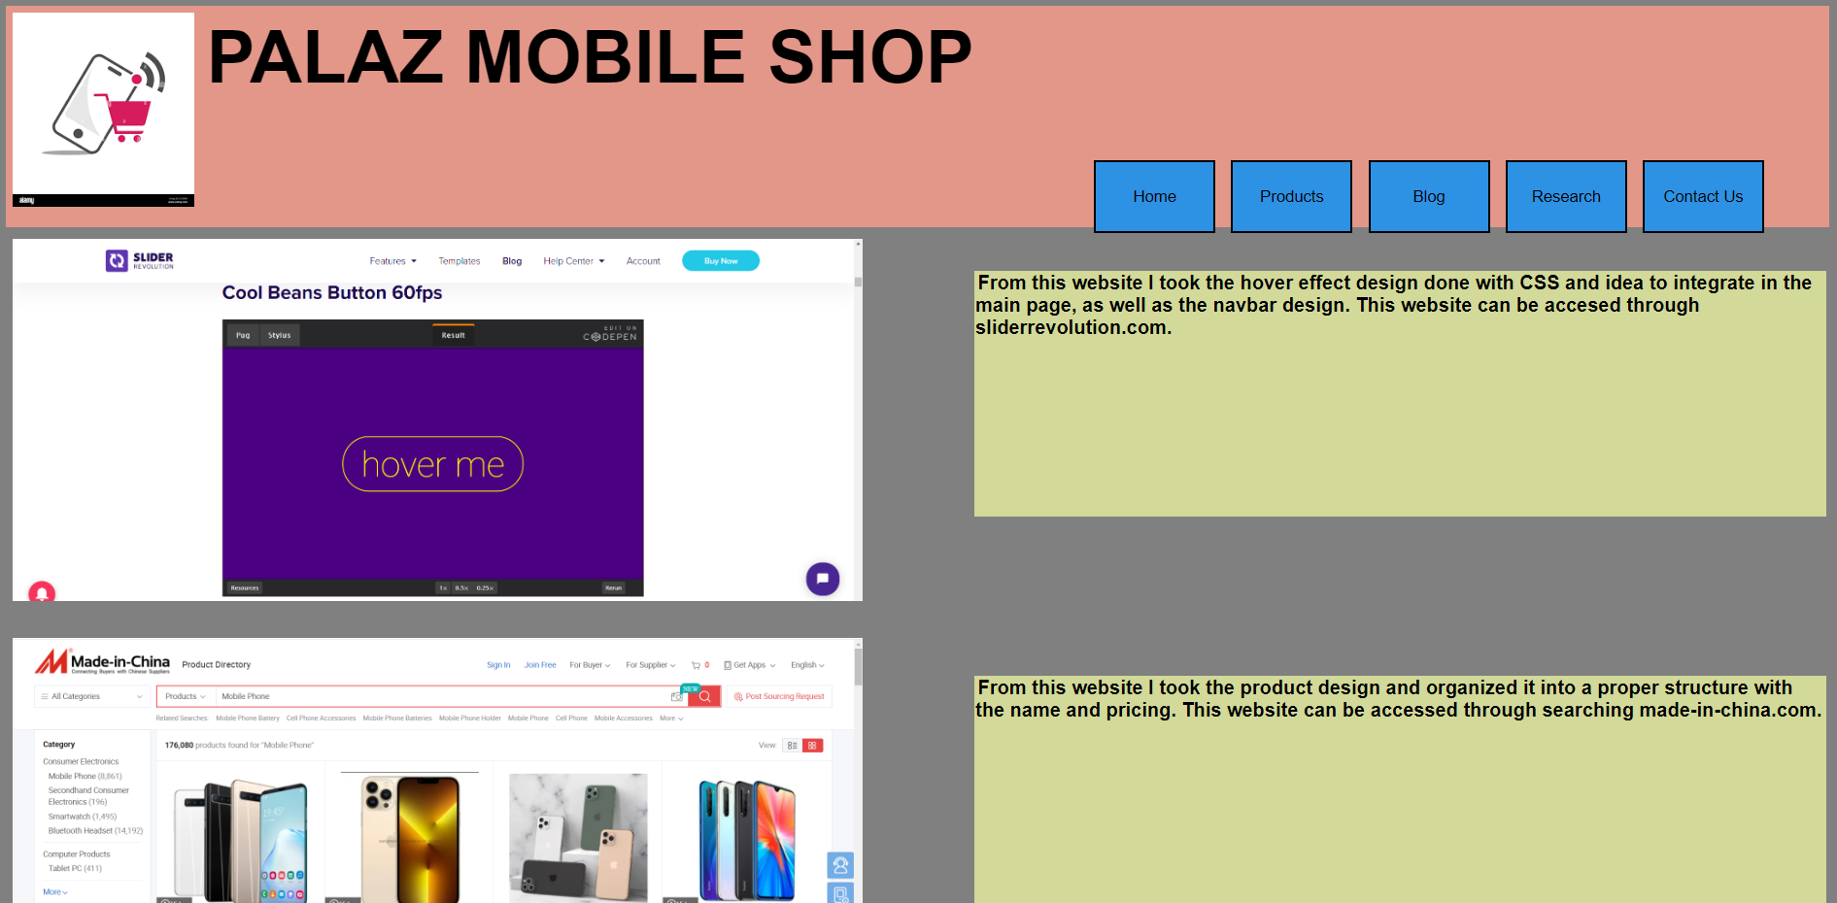**3.4.2 The Actual Research Page**

Figure 11 Research Page 2

Figure 12 Research Page 1

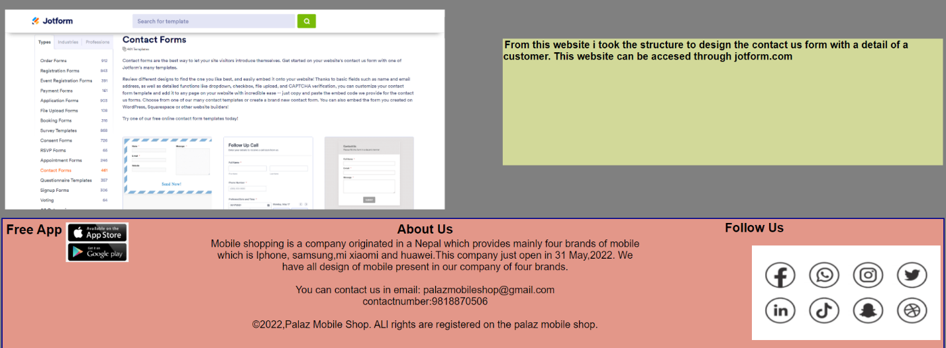

Figure 13 Research Page 3

## 3.5 Contact US Page

This is the last webpage of this website where there is the submission form of the customer data where it includes first name, last name, number, email and gender along with the message related to the their problems about the product and also to their difficulties. In this webpage the header and the footer is same as the homepage. In this webpage the JavaScript is apply for this form whether it is filled or not along with the output.

### **3.5.1 Wireframe of Contact US Page**

Figure 14 Balsamiq of Contact us Page

### **3.5.2 The Actual Contact us Page**

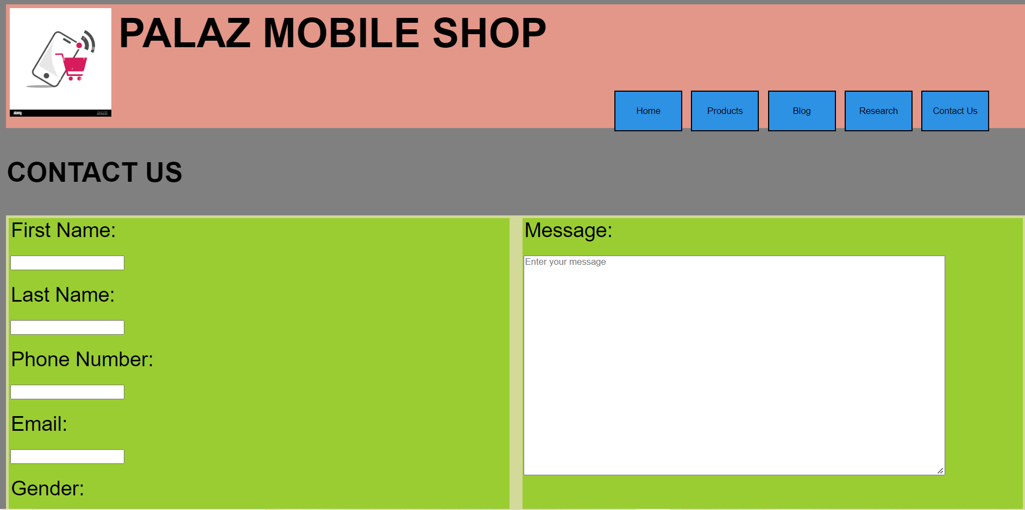

Figure 15 Contact Us Page 1

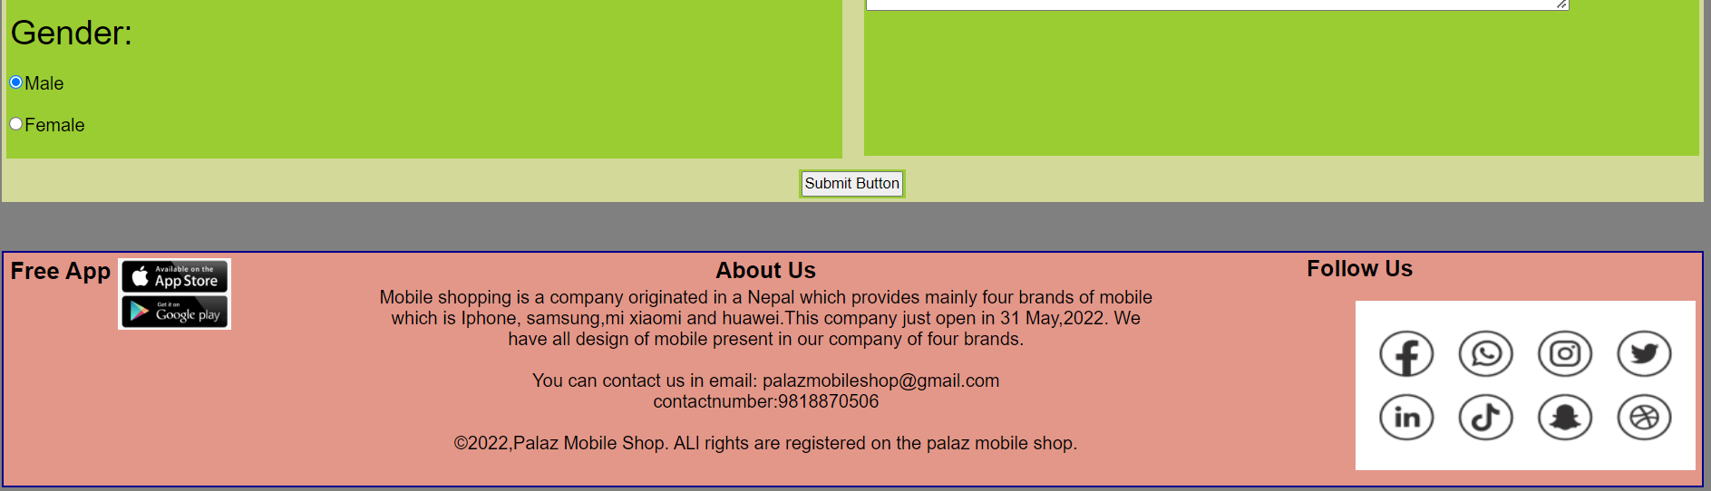

Figure 16 Contact Us Page 2

# **4. TESTING**

## 4.1 Test 1

|  |  |
| --- | --- |
| **Objective** | To change the image of a banner in every 2 seconds interval. |
| **Action** | * Variable “i” was assign as 0. A variable images was declared with the array of images and set interval was assigned as 2000 i.e. 2 second. * A function name changeImg() was created where a variable images was declare to get value by getting the element id of image of banner declared as id ‘slide’ and the if else statement was inside the function. * In if and else statement, if i is less than the length of array, 1 is subtracted to the variable i else i is assigned as 0 automatically due to else. * After the condition is checked the picture in array changes every 2 second automatically. |
| **Expected Result** | The image of a banner should change in every 2 second automatically. |
| **Actual Result** | The image of a banner is changed in every 2 second automatically. |
| **Test** | The test was successful. |

Table 1 Test 1

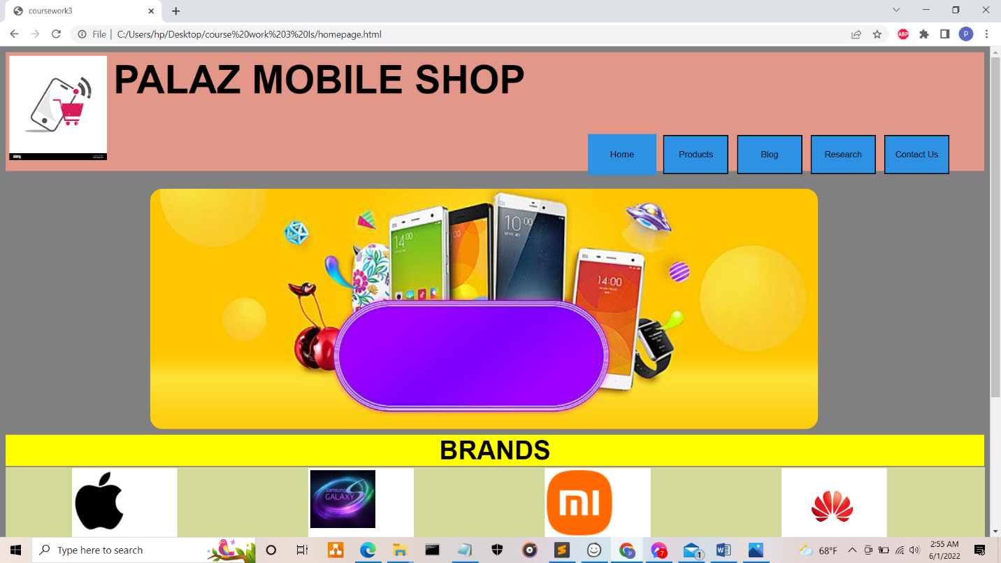

Figure 17 Test 1 screenshot 1

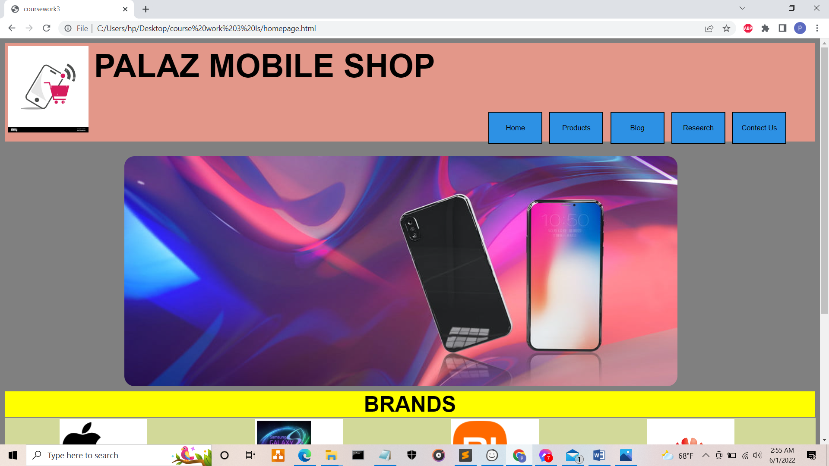

Figure 18 Test 1 screenshot 2

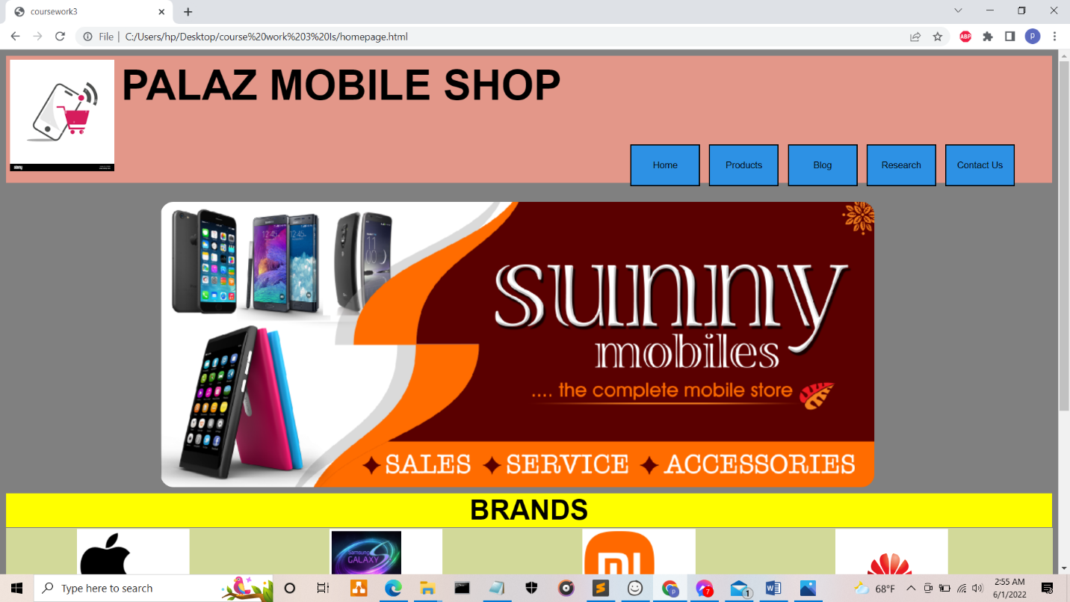

Figure 19 Test 1 screenshot 3

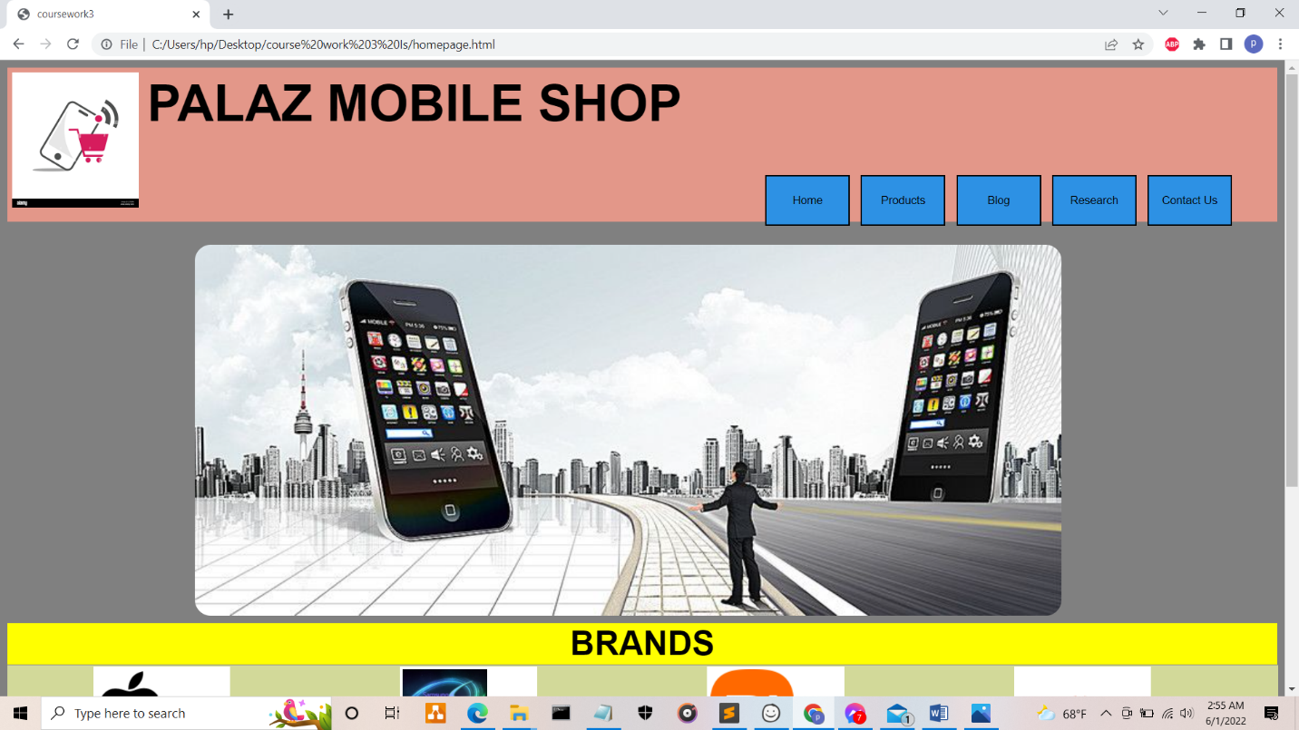

Figure 20 Test 1 screenshot 4

## 4.2 Test 2

|  |  |
| --- | --- |
| **Objective** | Form validation |
| **Action** | * A function named validation() was created. Inside the function six variables were created which are firstName, lastName, phoneNumber, email, gender and messageDetails where all six took the value from the form name “messageForm”. * Then, the if else statement is created where if firstName, lastName, phoneNumber, email, gender and messageDetails were empty, alert pops was shown with the message “Please enter the value!!!” else alert pops up was shown with the message “Thank you for the submission” |
| **Expected Result** | Alert pop up box should be shown with a message after the submission of form. |
| **Actual Result** | Alert box pops up will be shown along with the message according to the user input. |
| **Test** | The test was successful. |

Table 2 Test 2

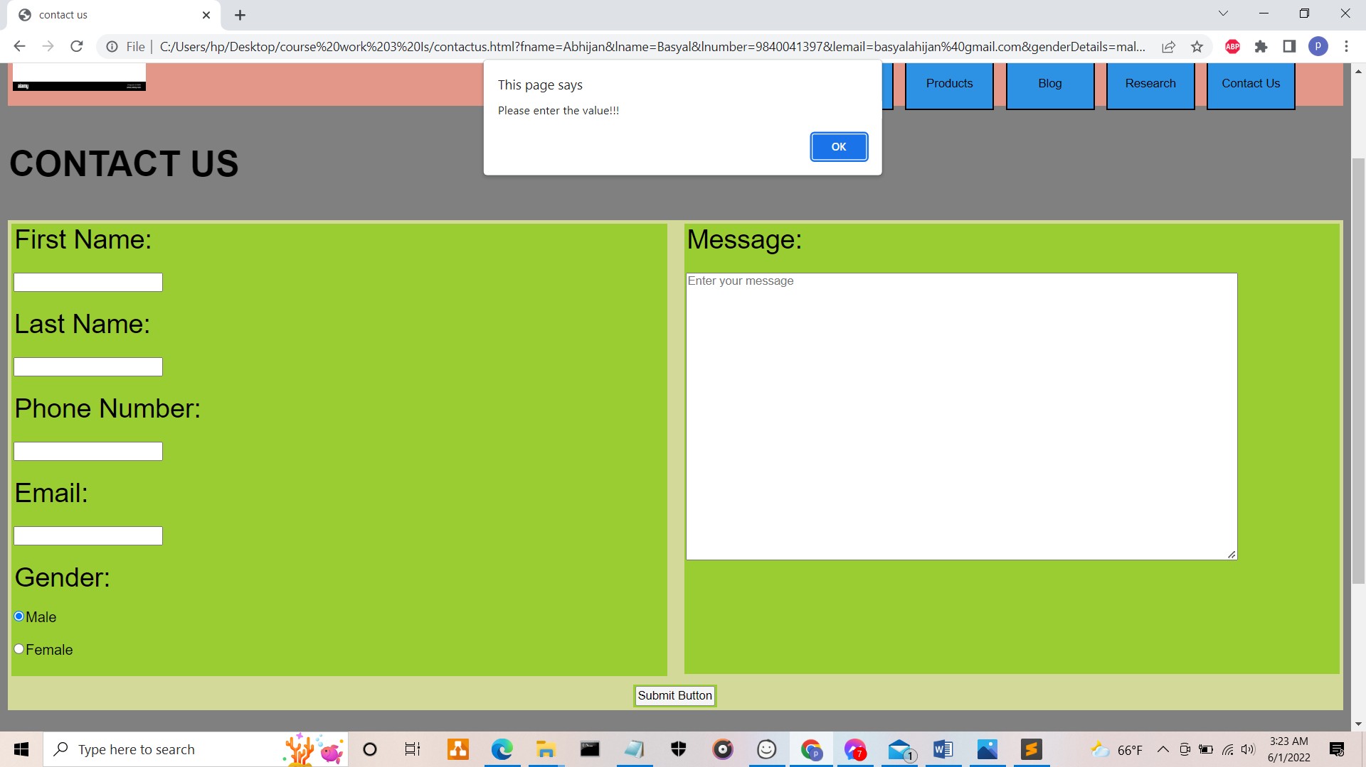

Figure 21 Test 2 screenshot 1

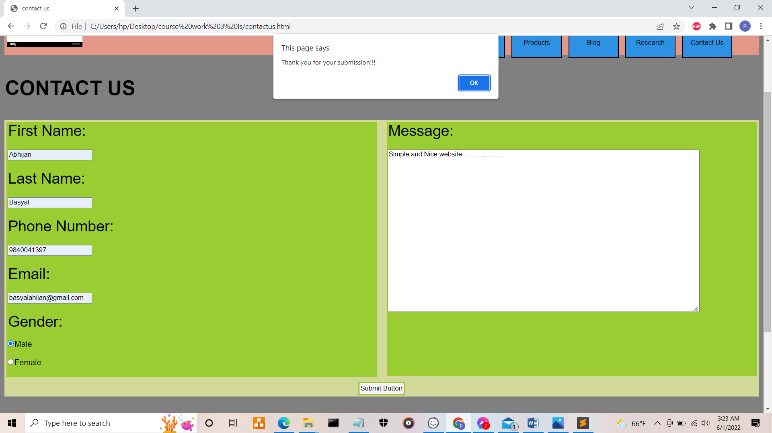

Figure 22 Test 2 screenshot 1

## 4.3 Test 3

|  |  |
| --- | --- |
| **Objective** | To change the background colour of products in every 2 seconds interval |
| **Action** | * Variable “i” was assign as 0. * A function name change() was created where in the function two variable is formed i.e. doc and color where in the doc the id pros is called and in the color variable the different color is added along with the arrays. * Then the background color is put by doc.style.backgoundColor equating with color with the variable i. After that the arithmetic is done where the variable i is equal to the (i + 1)% color.length. * Outside the fuction name change() the set interval was assigned as 2000 i.e. 2 second. |
| **Expected Result** | The background colour of products should change in every 2 second automatically. |
| **Actual Result** | The background colour of products is changed in every 2 second automatically. |
| **Test** | The test was successful. |

Table 3 Test 3

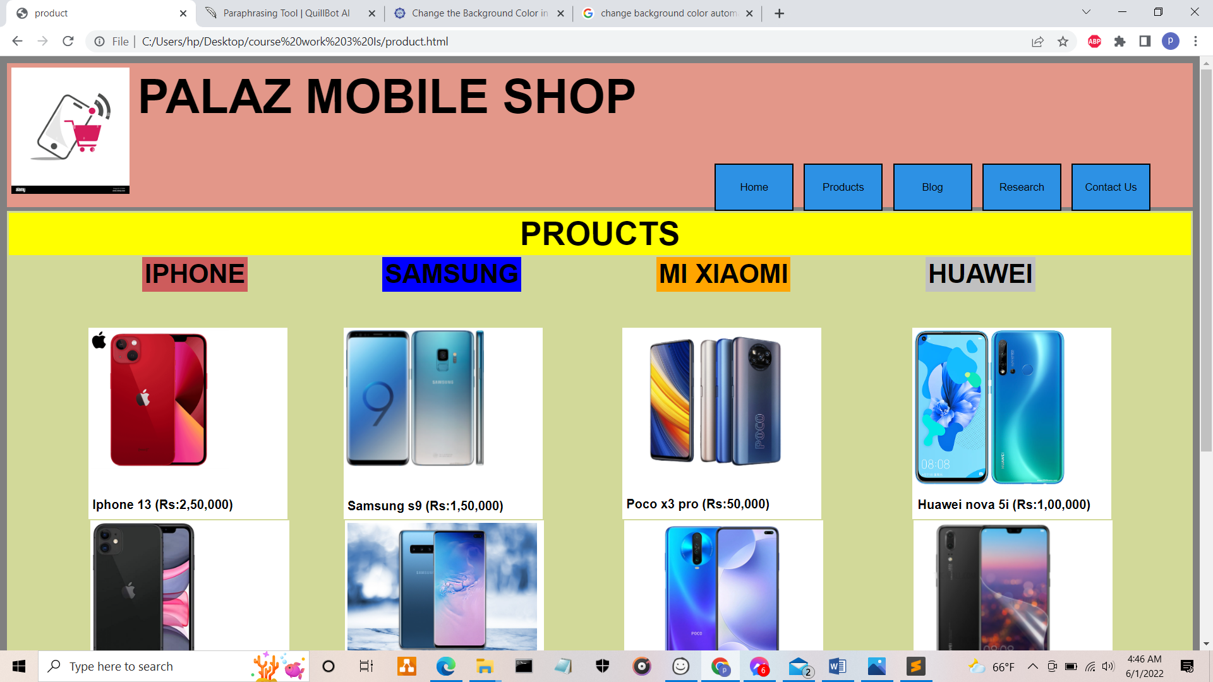

Figure 23 Test 3 screenshot 1

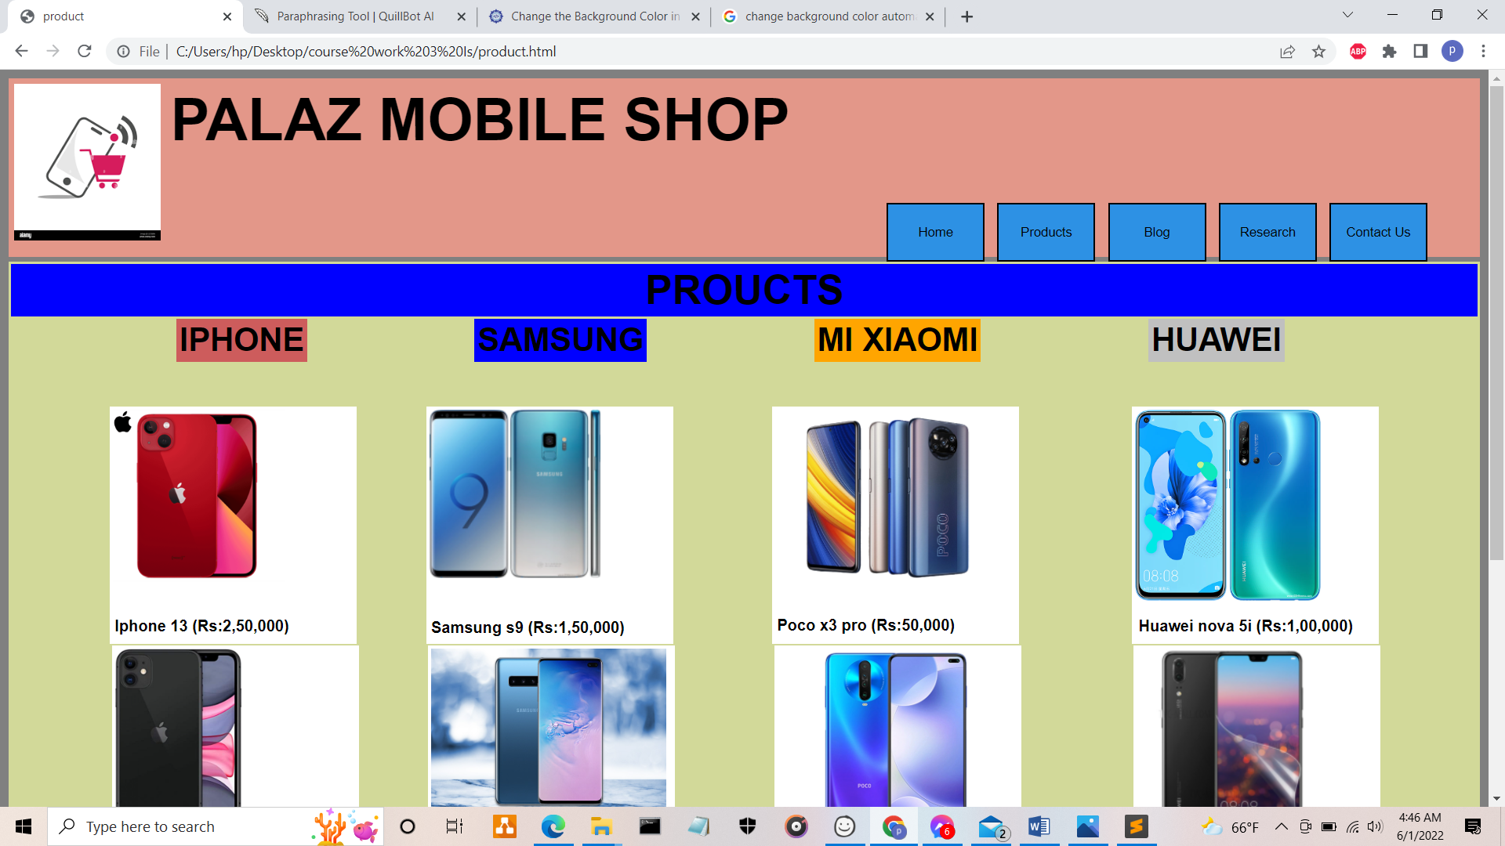

Figure 24 Test 3 screenshot 2

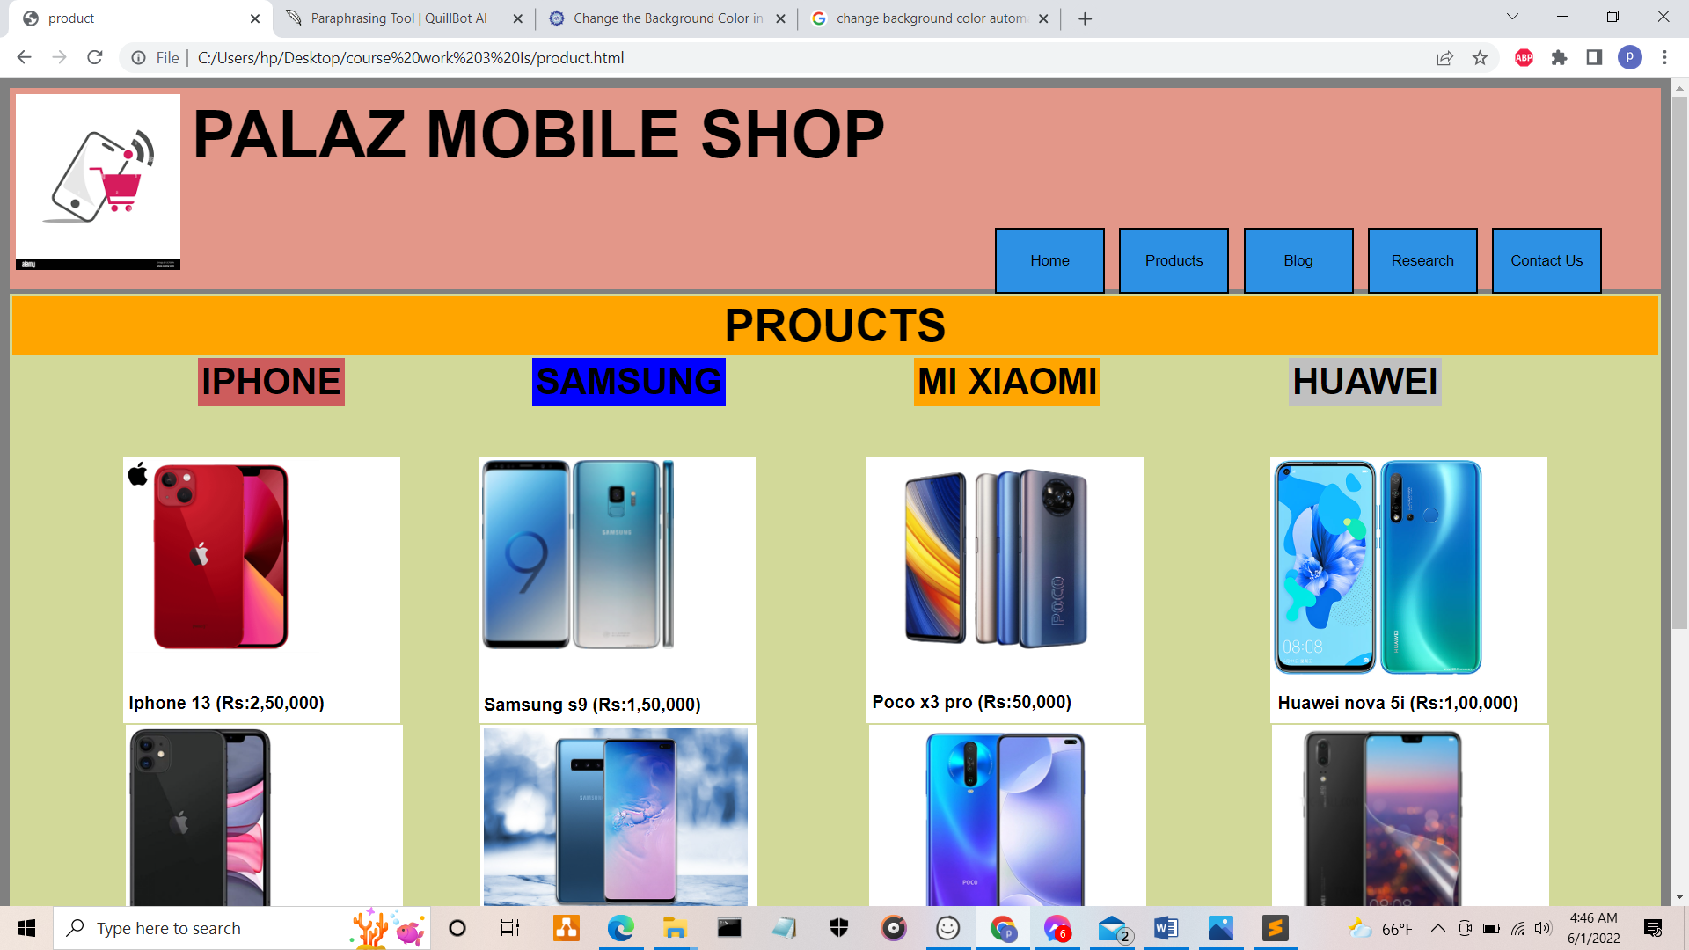

Figure 25 Test 3 screenshot 3

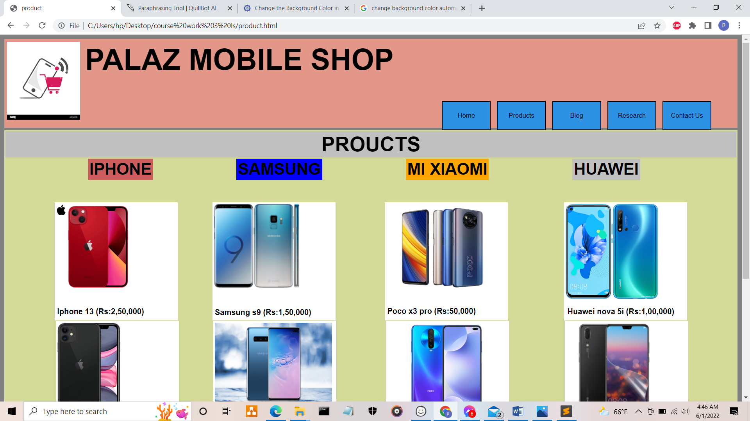

Figure 26 Test 3 screenshot

## 4.4 Test 4

|  |  |
| --- | --- |
| **Objective** | To increase the size of the product items of the product webpage |
| **Action** | * IPhone brand product was called as a class v, Samsung as a x, MI xiaomi as a y, Huawei as a z * In all class v, x, y and z, Using the CSS hover effect was added using the transition applying transform of 0.2s with the scale of 1.1 |
| **Expected Result** | Should increase and zooming the size of the product items along with the prices while hovering. |
| **Actual Result** | Increases and zooming of the size of the products items when hovered. |
| **Test** | The test was successful. |

Table 4 Test 4

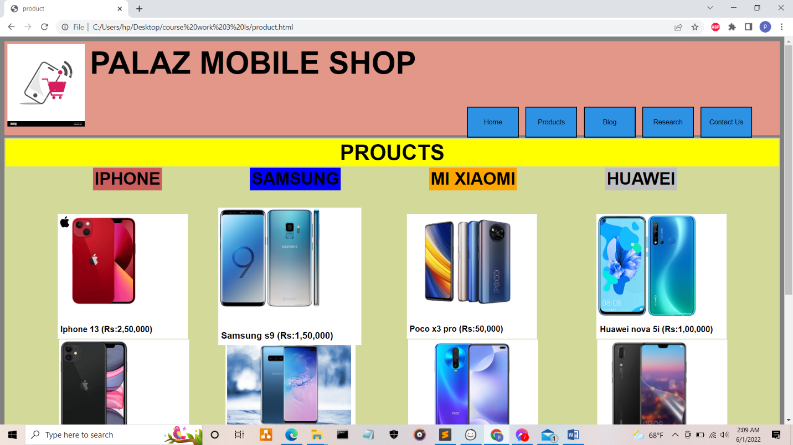

Figure 27 Test 4 screenshot

## 4.5 Test 5

|  |  |
| --- | --- |
| **Objective** | To change the webpage after clicking the buttons. |
| **Action** | * Webpages are linked with each other with the help of navigation bar and the HTML tag <a href=””> after that all the link are replace by putting a HTML tag <button> * All this webpages are internal and external linked through the tag <a href=””> with the button on navigation bar. |
| **Expected Result** | Should change the webpages after clicking on the button of navigation bar. |
| **Actual Result** | Webpages are changed after clicking on the button of navigation bar. |
| **Test** | The test was successful. |

Table 5 Test 5

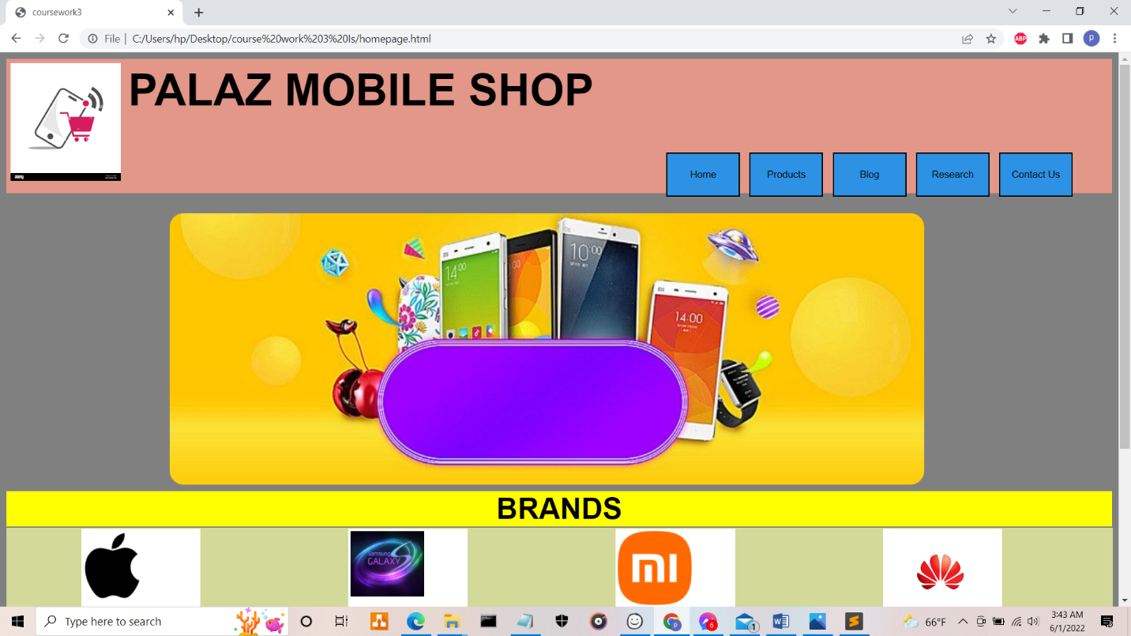

Figure 28 Test 5 screenshot 1

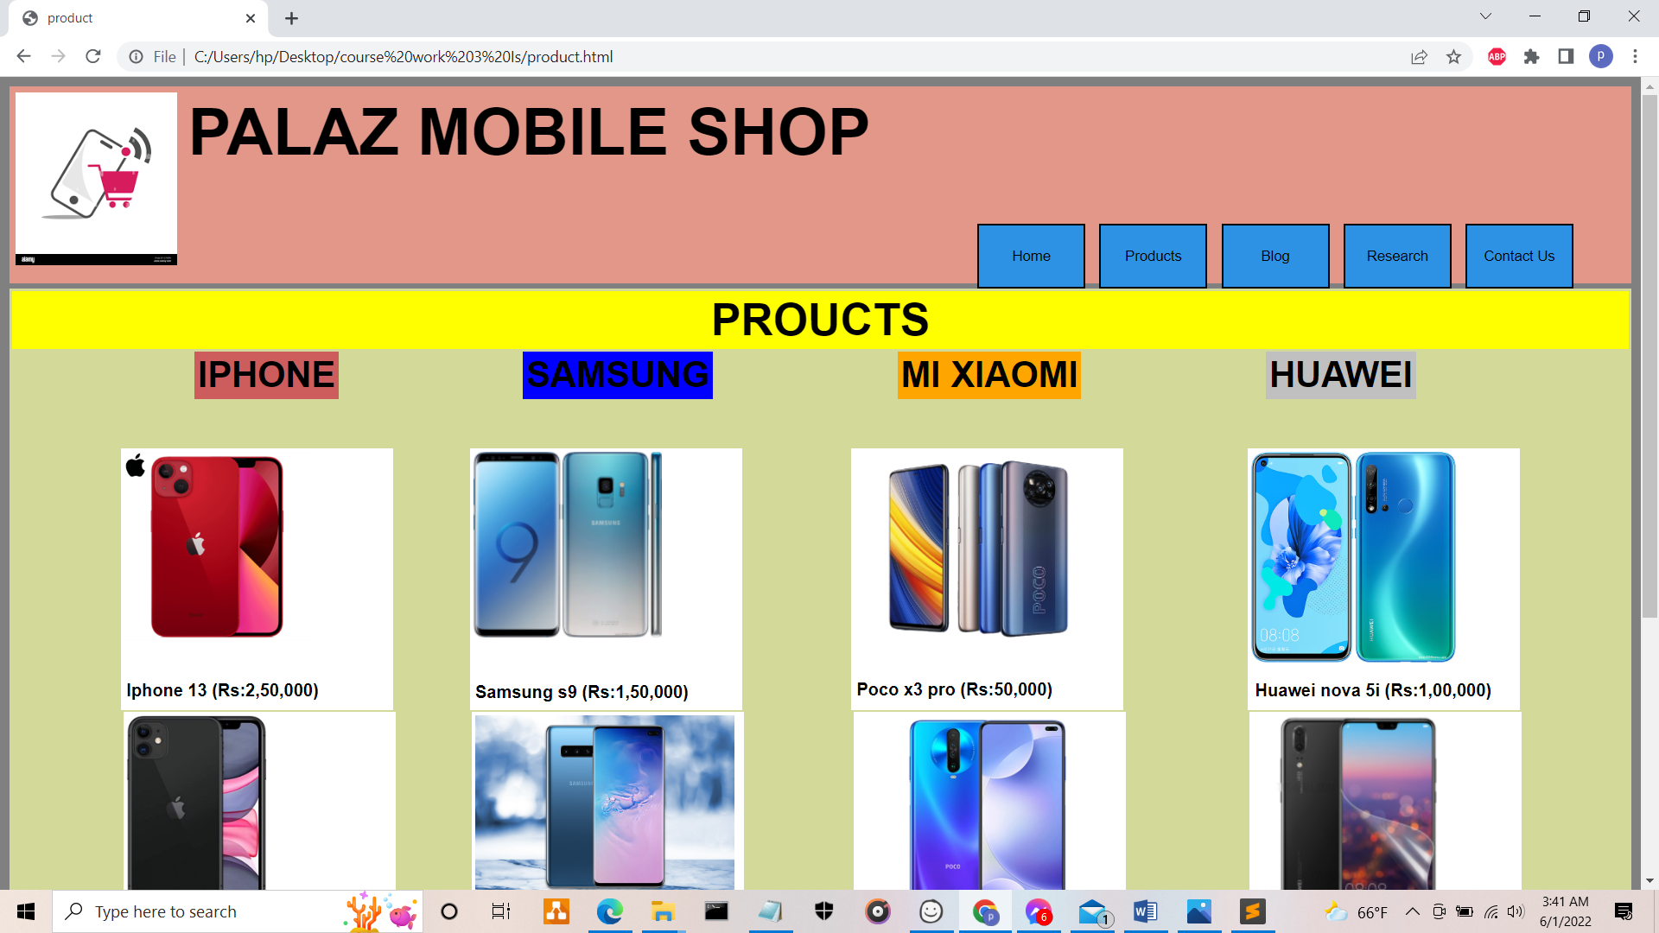

Figure 29 Test 5 screenshot 2

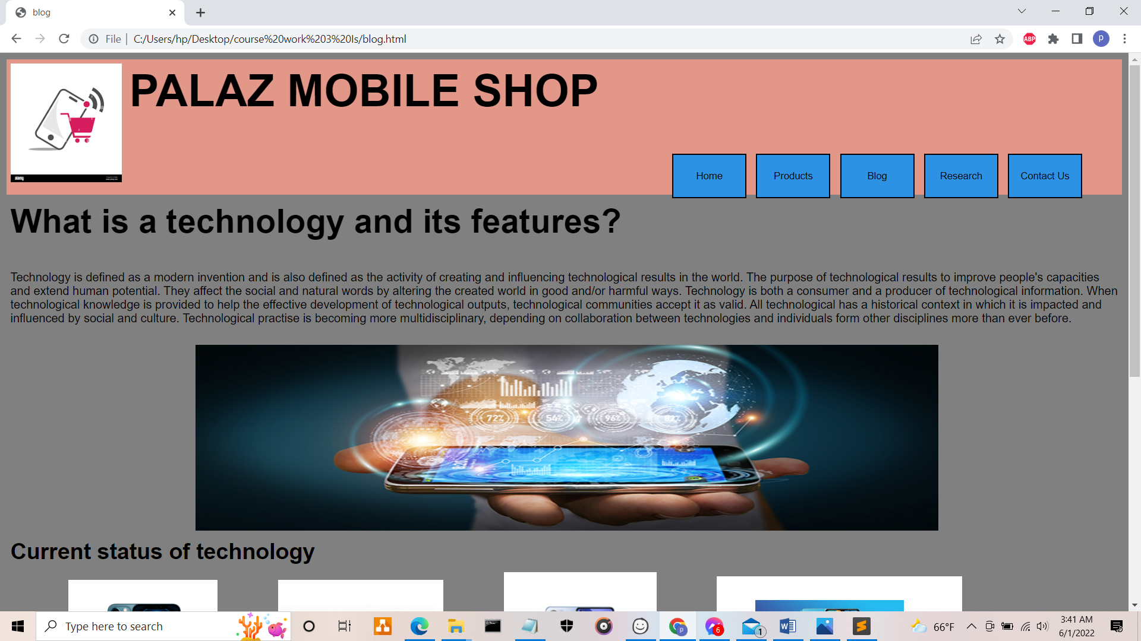

Figure 30 Test 5 screenshot 3

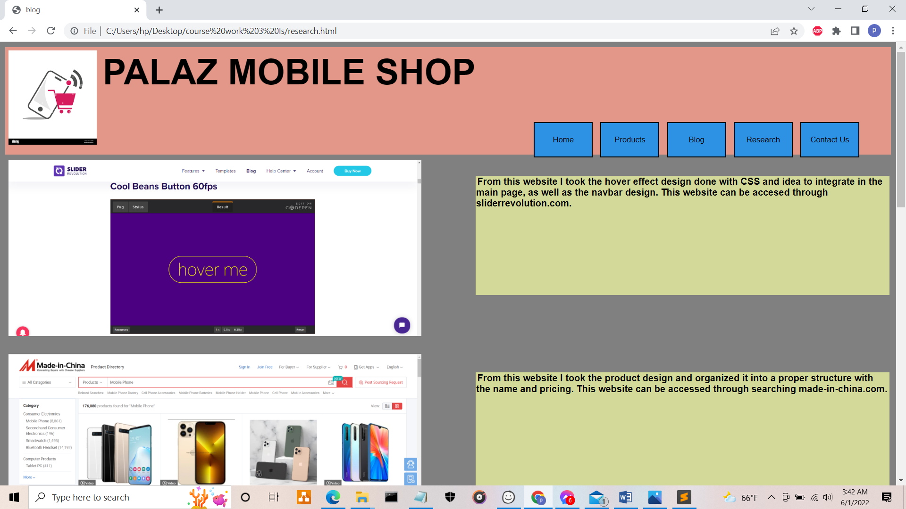

Figure 31 Test 5 screenshot 4

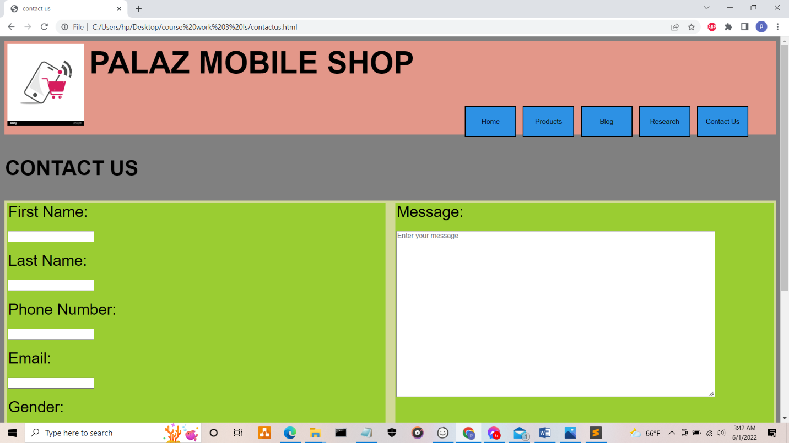

Figure 32 Test 5 screenshot 5

# **5. CONCLUSION**

In this coursework, it mainly includes the designing of the websites along with the five webpages. This webpage designing coursework was a bit difficult and interesting. For the first time I thought as an IT student making a website which make me fully interested to work in this project with a nice effort. The websites I have design is just a simple with a proper use of div tag. In this website designing for all the webpage I have used too many div tag to form a small letter also. My websites have five webpages where all the five webpages have the header, main and footer inside the body tag. All the header and the footer is same in all the webpages. The changes is in the main of all the five webpages. As this website is about the mobile shop where the title of my mobile shop is “PALAZ MOBILE SHOP”. This website includes the five webpages as I have said earlier which is home, product, blog, research and contact us. In this websites CSS is used for margin, colouring, padding and so on. There is also use of JavaScript in this website for banner changing images, contact us form valid or not.

For making the websites, I took the references of mainly five websites where I took the idea of structure of a content to design my webpages. I also use w3 school websites for the confusion of coding. All the code is done in the sublime text tools and the documentation in the Ms word and the websites at Google. I take the guidelines from the teacher along with the solving of the confusion for making webpages. After researching I get the idea about the coding, structure for designing webpage, linking the webpage.

# **BIBLIOGRAPHY**

Balsamiq Studios, LLC, 2008-2022. *Introduction to Balsamiq Wireframes for Desktop - Balsamiq for Desktop Documentation | Balsamiq.* [Online]   
Available at: https://balsamiq.com/wireframes/desktop/docs/intro/  
[Accessed 29 May 2022].

Tutorials point, 2022. *Sublime Text - Introduction.* [Online]   
Available at: https://www.tutorialspoint.com/sublime_text/sublime_text_introduction.htm#  
[Accessed 29 May 2022].

wikipedia, 2022. *Home page - Wikipedia.* [Online]   
Available at: https://en.wikipedia.org/wiki/Home_page#:~:text=A%20home%20page%20(or%20homepage,when%20the%20application%20first%20opens.  
[Accessed 30 May 2022].

# **APPENDIX**

